Project Title: Who Eats Whom
Team Members: Lavanya Middha, Surabhi Ravindran Nair

1. Project Goal
Our objective is to analyze feeding interactions across species to uncover ecological patterns that help ecologists make more informed, data-driven decisions.

2. Data Exploration & Pre-Processing
2.1 Data Source
We extracted observational interaction data from iNaturalist. Each feeding interaction appears as a pair of linked observations:
- One from predator → prey,
- One from prey → predator,
connected by a partner observation ID.
2.2 Data Cleaning
From 7,661 total observations, we identified 2,013 problematic entries, including:
- 1,948 empty values
- Invalid formats (e.g., /observations/new?copy=<id> or URLs with #activity)
- Incorrect or unclear taxon names (e.g., “Apple”)
We kept only entries with quality_grade = “research”, indicating expert-verified observations from iNaturalist.
All NA values were removed, leaving us with a clean subset for analysis.
2.3 Data Structuring
- Created a data dictionary to validate taxa and observation fields.
- Built a new cleaned dataframe where each row contains one predator–prey interaction.
- After cleaning:
- obs_df – valid predator–prey pairs with complete information.
- null_df – pairs where predator or prey data was invalid or missing.
- Split the cleaned dataset into:
  - Taxa dictionary CSV – scientific name, common name, iconic taxon, taxon ID
  - EATS CSV – predator, prey, location, Feeding type (predation, pollination, parasitism, etc.)

3. Graph Modeling in Neo4j
3.1 Preparation
We completed multiple Neo4j foundational courses to understand graph concepts, Cypher, and modeling techniques.
3.2 Graph Construction
- We imported:
- Taxa nodes, and
- EATEN_BY relationships representing feeding interactions,
- Installed essential Neo4j libraries:
- Graph Data Science (GDS)
- APOC Procedures

4. Preliminary Analysis
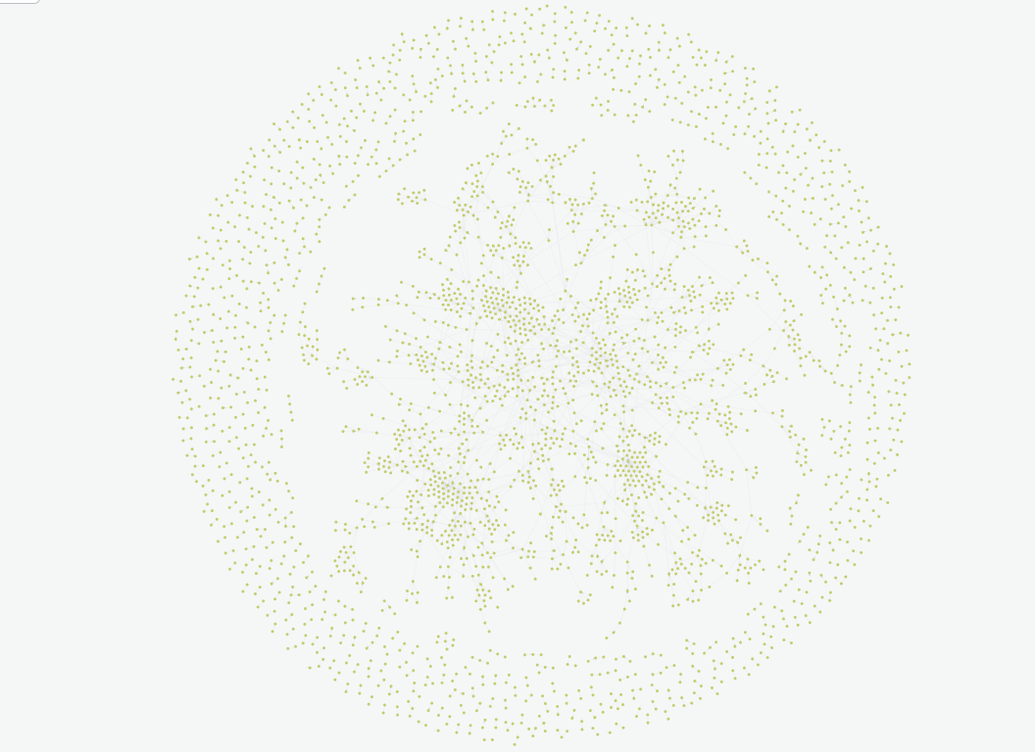
4.1 Strongly Connected Cycles
Visual graph layouts revealed large strongly connected components, suggesting circular or misreported feeding links.
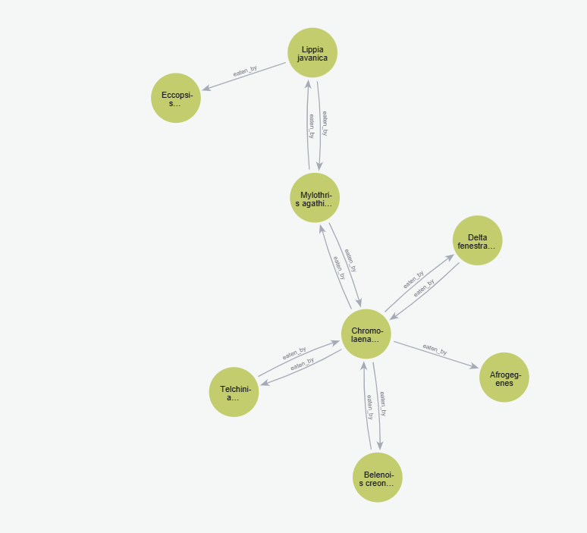
4.2 Key Findings
From the centrality and degree analyses:
• Critical Species (Highest Betweenness Centrality)
- Apis mellifera (Western Honey Bee) – betweenness 649.5
→ Indicates it acts as a major connector in the network.
• Predator With the Most Unique Prey - Ardea herodias (Great Blue Heron)
Top Five:
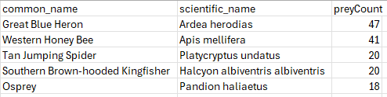
• Most Eaten Prey (Highest In-Degree) - Lepidoptera (Butterflies & Moths) – eaten by 38 predators.
Top Five:
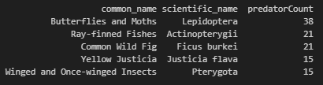
• Isolated Species
Species that neither eat nor are eaten (only self-links). These appear due to observation noise or taxonomy issues. This needs to be further validated.
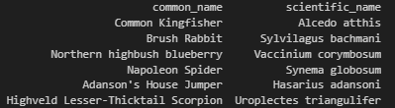

5. Identified Data Issues & Discrepancies
Several issues reduce the trustworthiness of current analysis:
5.1 Biological Inconsistencies
- Butterflies and moths being labeled as “bottom feeders” (ecologically incorrect).
- Some research-grade observations are incorrectly reversed:
  - Predator mislabeled as prey, or vice-versa.
- Instances of plant-eating misclassified as predation.
5.2 Interaction-Type Errors
Observations mis-tagged as predator–prey include:
- Pollination
- Hemiparasitism
- Endoparasitism
- Epiparasitism
5.3 Structural Problems
- Numerous cases of species “eating themselves”.
- Misaligned chains leading to incorrect keystone species or prey hierarchy outputs.
- Data sparsity causing distorted ecological interpretations.
All supported by observations summarized in the final page.

6. Current Assumptions & Interpretation
- Many inconsistencies stem from lack of observations for certain groups (e.g., decomposers).
- Sparse data leads to inaccurate trophic-level inferences, incorrect chains, or misleading critical species metrics.
- Additional validation is required before expanding or fully trusting the network.

7. Next Steps
7.1 Expert Review
- We have validated Plantae, Fungi, Chromista datasets and plan to review patterns with Brad, our collaborating ecologist.
- Need his guidance on interpreting non-predatory interactions such as pollination and parasitism.
7.2 LLM-Based Interaction Validation
We aim to build an LLM-powered validation pipeline that will:
- Check if interactions are biologically plausible,
- Cross-verify with authoritative ecological sources,
- Flag or remove suspicious interactions before they enter the graph.
7.3 Geographical Filtering
- Restrict dataset to U.S. observations to create a more reliable, ecologically coherent subset.
7.4 Structural Improvements
- Define trophic attributes (producers, primary consumers, secondary consumers).
- Add functional feeding groups: herbivore, carnivore, omnivore, etc.
- Create a scalable data dictionary and schema before repopulating the full dataset.

8. Final Summary
Using iNaturalist data, we built a cleaned, structured predator–prey dataset and modeled it in Neo4j for ecological network analysis. Early insights reveal important species and feeding patterns but also significant misclassifications and inconsistencies that limit the accuracy of results. The next phase focuses on expert consultation, LLM-powered validation, geographic filtering, and trophic classification to create a scientifically robust, scalable food-web model

